|  |  |
| --- | --- |
| *Pacific Gas and Electric Company* | |
| Release 9.3.1 Installation Guide | |
|  |  |
|  |  |
| Project | ED AM/GIS |
|  |  |
| Prepared by | Subhankar Baidya |
| Date | 2/2/2015 |
| Version | 1.0 |
| Version Type | In Progress |

|  |  |  |  |
| --- | --- | --- | --- |
| Revision History | | | |
| Document # | Date | Author | Summary of Changes |
| 1.0 |  | Subhankar Baidya | Initial Document Creation |
| 1.1 | 1/29/2015 | Rob Rader | Checked TFSs in root table and matched document to master ticket. |

# Introduction

## Purpose

This document is intended to detail the implementation and configuration steps required to implement Release 9.3.1 Installation Guide. This document describes the various configuration aspects required to complete any manual or automatic patch associated with this release. Each section in this document contains the steps required to patch the system in production.

## Terms Used

|  |  |
| --- | --- |
| OOTB | Out of the box. Unmodified from the commercial version. |
| TFS | Team Foundation Server |

## External Documents

Referenced are any external configuration documents or exports. These are documents that contain more detailed information about configuring a system or documents that can be loaded into an application to perform the configuration detailed in this document.

1. Trans Unit Python scripts location:
   1. \\sfetgis-nas01\sfgispoc_data\ApplicationDevelopment\IBM_Delivery\ReleaseInstructions\9.3.1\Python scripts

## List Of Fixes

Below is the list of change requests detailing all fixes for the data model for this release:

|  |  |
| --- | --- |
| **Item Number** | **Title** |
| [TFS 18992](http://edappgistfsprd1:8080/tfs/web/wi.aspx?pcguid=15e9a9d1-95cb-4dd0-abfe-5af14ae6201f&id=18992) | Master TFS for intermediate Data Model 9.3B manually applied. |
| **18980** | **Drop and recreate Conduit System Anno in G2D** |
| **19006** | **Apply Production Connectivity Rules** |
| **19023** | **Update Relationship Aliases** |
| **18979** | **EDGIS.NeutralConductorAnno Annotation Class configuration** |
| **19031** | **Apply ArcFM Properties to support 9.3B** |
| **19020** | **Update Map Prod 1.0 and 2.0 Tables** |
|  |  |
| **Item Number** | **Title** |
| [TFS 18842](http://edappgistfsprd1:8080/tfs/web/wi.aspx?pcguid=15e9a9d1-95cb-4dd0-abfe-5af14ae6201f&id=18842) | Master TFS Data Model 9.3.1 |
| **19031** | **Apply ArcFM Properties to support 9.3B.** |
| **18971** | **Alter Expression of StepDownAnnotation to correct short annotation.** |
| **18973** | **Reconfigure DeactivatedElectricLineSegment and NeutralConductor for UFM** |
| **18974** | **Configure DCConductor and Secondary Conductor for X-Section Annotation** |
| **18975** | **Remove X-Section Conductor AU** |
| **18976** | **Configure Duct Sync AU** |
| **18977** | **Configure Conductor in Conduit Validation Rule** |
| **18978** | **Update Overhead Switch ComplexDeviceIDC field properties** |
| **18980** | **Drop and recreate Conduit System Anno in G2D** |
| **19000** | **Transformer Type Domain Change for : Trans Unit Type Overhead , Trans Unit Type Surface , and Trans Unit Type Subsurface** |
| **19012** | **Remove relationship rules from ProtectiveDeveice_Inverter and add PGE_Generator model name to inverter.** |
| **19006** | **Apply Production Connectivity Rules** |
| **19023** | **Update Relationship Aliases** |
| **19026** | **Update Direction attribute on ConduitSystem** |
| **18979** | **EDGIS.NeutralConductorAnno Annotation Class configuration** |
| **19020** | **Update Map Prod 1.0 and 2.0 Tables** |
| **19062** | **Assign Nominal Voltage AU to Primary Overhead Conductor : PriOHConductor** |

## Summary of Steps to Complete Install

Contents

1 Introduction 3

1.1 Purpose 3

1.2 Terms Used 3

1.3 External Documents 3

1.4 List Of Fixes 4

1.5 Summary of Steps to Complete Install 6

2 Open a Database Connection in ArcCatalog 9

3 TFS 19031 Apply ArcFM Properties to support 9.3 10

4 TFS18973 Reconfigure DeactivatedElectricLineSegment and NeutralConductor for UFM 11

5 TFS18974 Configure DCConductor and Secondary Conductor for X-Section Annotation 12

6 TFS18975 Remove X-Section Conductor AU 14

7 TFS18976 Configure Duct Sync AU 15

8 TFS18977 Configure Conductor in Conduit Validation Rule 17

9 TFS18978 Update Overhead Switch ComplexDeviceIDC field properties 19

10 TFS18971 Alter Expression of StepDownAnnotation to correct short annotation. This is to fix bug 18758 20

11 TFS18980 Drop and recreate Conduit System Anno 21

11.1 Configuration Steps 21

12 TFS 19000 Transformer Type Domains Change 36

13 TFS19012 Remove Relationship Rules and add Pge_Generator Model Name to Inverter. 37

14 TFS19006 Apply Production Connectivity Rules 39

15 TFS 18979: EDGIS.NeutralConductorAnno Annotation Class configuration 40

16 Update relationship aliases – Change the “Labels” (Forward and Backward) 41

16.1 EDGIS.ConduitSystem50AnnoRel 42

16.2 EDGIS.CapacitorBank50AnnoRel: 54

16.3 EDGIS.CrossSection50AnnoRel: 55

16.4 EDGIS.CustAgreeNumber50AnnoRel: 56

16.5 EDGIS.DCConductor50AnnoRel: 57

16.6 EDGIS.DCDevice50AnnoRel: 58

16.7 EDGIS.DCRectifier50AnnoRel: 59

16.8 EDGIS.DeactivatedElecLineSeg50AnnoRel: 60

16.9 EDGIS.DeliveryPoint50AnnoRel: 61

16.10 EDGIS.DeviceGroup50AnnoRel: 62

16.11 EDGIS.DistBusBar50AnnoRel: 63

16.12 EDGIS.DynProtDevice50AnnoRel: 64

16.13 EDGIS.FaultIndicator50AnnoRel: 65

16.14 EDGIS.Fuse50AnnoRel: 66

16.15 EDGIS.JobNumber50AnnoRel: 67

16.16 EDGIS.NetworkProtector50AnnoRel: 68

16.17 EDGIS.NeutralConductor50AnnoRel: 69

16.18 EDGIS.PrimaryGeneration50AnnoRel: 70

16.19 EDGIS.PriOHConductor50AnnoRel: 71

16.20 EDGIS.PriUGConductor50AnnoRel: 72

16.21 EDGIS.SecOHConductor50AnnoRel: 73

16.22 EDGIS.SecondaryGeneration50AnnoRel: 74

16.23 EDGIS.SecUGConductor50AnnoRel: 75

16.24 EDGIS.StepDown50AnnoRel: 76

16.25 EDGIS.StreetLight50AnnoRel: 77

16.26 EDGIS.Substation50AnnoRel: 78

16.27 EDGIS.SubsurfaceStructure50AnnoRel: 79

16.28 EDGIS.SupportStructure50AnnoRel: 80

16.29 EDGIS.Switch50AnnoRel: 81

16.30 EDGIS.Transformer50AnnoRel: 82

16.31 EDGIS.VaultPoly50AnnoRel: 83

16.32 EDGIS.VoltageRegulator50AnnoRel: 84

17 TFS19026 – Update Direction attribute on ConduitSystem 85

18 TFS 19062 Assign Nominal Voltage AU to Primary Overhead Conductor : PriOHConductor 86

19 TFS 19020 Update Map Prod 1.0 and 2.0 Table updates 88

20 Data Model Version Table 91

21 Known Issues 92

# Open a Database Connection in ArcCatalog

1. Open ArcCatalog.
2. Within the Catalog Tree, expand “Database Connections” and open the active connection for this process. This is the connection that is referenced in the change request associated with this document (EDGIS<DB name in the format X#Y> )

# TFS 19031 Apply ArcFM Properties to support 9.3

Apply the ArcFM Properties one at a time by feature class to the database to be updated.

1. Go to the following location:

\\sfetgis-nas01\sfgispoc_data\ApplicationDevelopment\IBM_Delivery\ReleaseInstructions\9.3.1

1. Copy all xml files locally.
2. Right click the target database and select ArcFM XML Import.
3. Select an xml file to import. Ensure that the Overwrite option is selected.
4. Click Import.
5. Repeat the above for all xml files.

NOTE: This TFS and steps must be done before the other fiel properties steps in this document.

# TFS18973 Reconfigure DeactivatedElectricLineSegment and NeutralConductor for UFM

1. Right-click on DeactivatedElectricLineSegment in the Electric dataset and select ArcFM Properties Manager
2. Select the Model Names tab

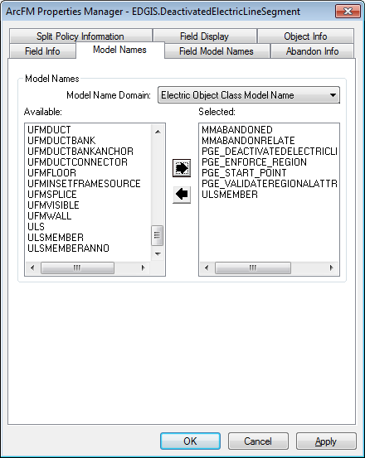

1. Assign the ULSMEMBER model name from the Electric Object Class Model Name domain.
2. Right-click on NeutralConductor in the Electric dataset and select ArcFM Properties Manager
3. Select the Model Names tab
4. Assign the ULSMEMBER model name from the Electric Object Class Model Name domain.

# TFS18974 Configure DCConductor and Secondary Conductor for X-Section Annotation

1. Right-click on **DCConductorInfo** in the root and select **ArcFM Properties Manager**
2. Select the **Object Info** tab
3. Under **On Feature Update**, select **<Multiple…>**
4. Add **PGE DCConductor LabelText** AU to the list of configured AU’s

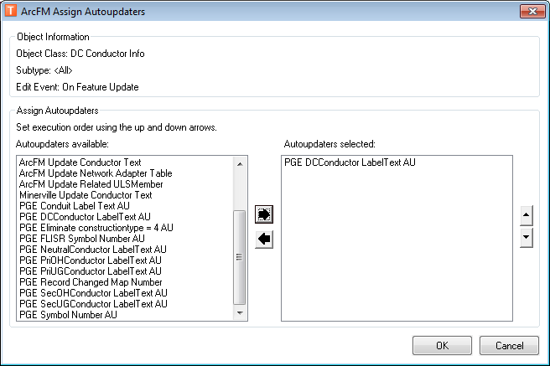

1. Click **OK**
2. Click **OK**
3. Right-click on **SecUGConductor** in the Electric dataset and select **ArcFM Properties Manager**
4. Select the **Model Names** tab
5. Assign the **PGE_SECONDARYUGCONDUCTOR** model name from the **PGE ED Object Class Model Name** domain.

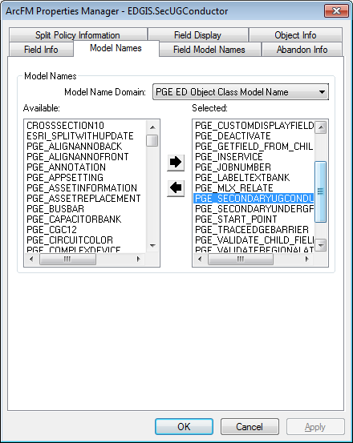

1. Click **OK**
2. Click **OK**

# TFS18975 Remove X-Section Conductor AU

1. Right-click on PriUGConductor in the Electric dataset and select ArcFM Properties Manager
2. Select the Object Info tab
3. Under “On Feature Create”, select “<Multiple…>”
4. Remove PGE Cross Section Conductor Anno AU from the list of configured AU’s

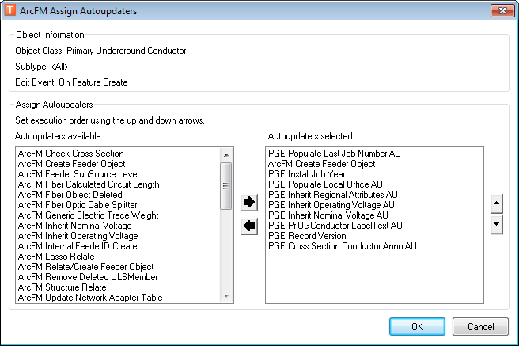

1. Click on OK
2. Under “On Feature Update”, select “<Multiple…>”
3. Remove PGE Cross Section Conductor Anno AU from the list of configured AU’s
4. Ensure that the “ArcFM Check Cross Section” AU is listed after the “PGE PriUGConductor LabelText AU”
5. Click on OK
6. Repeat steps 1 through 9 for the SecUGConductor and DCConductor feature classs

# TFS18976 Configure Duct Sync AU

1. Right-click on the database level node and select **Properties**
2. Select the **Domains** tab
3. Find the **PGE ED Field Model Name** domain and add the **PGE_DUCTSYNCATTR** model name

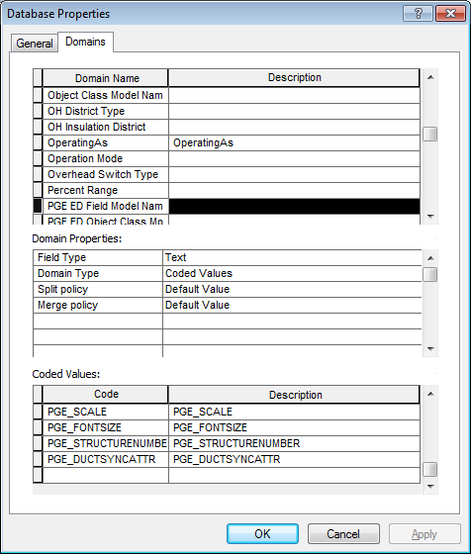

1. Click OK
2. Right-click on the **Duct** feature class in the UFM dataset and select **ArcFM Properties Manager**
3. Apply the new **PGE_DUCTSYNCATTR** model name to the following fields:

* FillType
* Bypass
* Condition
* VentIDC
* FiberOpticIDC

1. Right-click on the **ConduitSystem** feature class in the electric dataset and select **ArcFM Properties Manager**
2. In the **On Feature Update** event, select **<Multiple…>**
3. Assign the **PGE Sync Duct Attributes AU** to fire before the ArcFM Check Cross Section AU

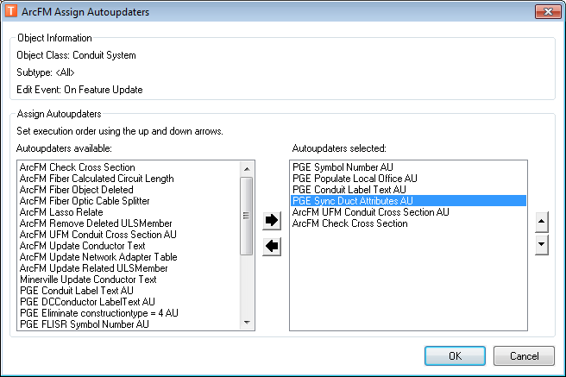

1. Click on **OK**
2. Click on **OK**

# TFS18977 Configure Conductor in Conduit Validation Rule

1. Right-click on the database level node and select **Properties**
2. Select the **Domains** tab
3. Find the **PGE ED Field Model Name** domain and add the **PGE_DIRECTBURYIDC** model name

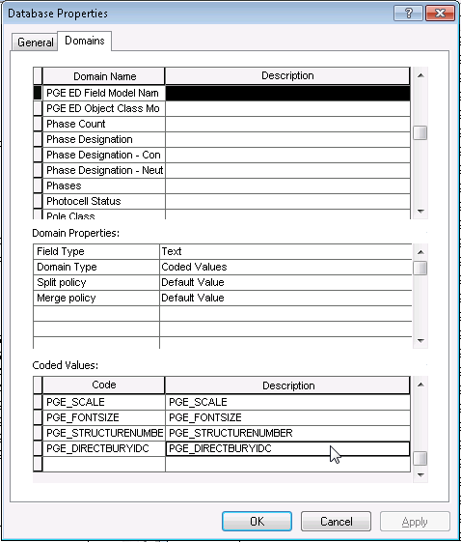

1. Click OK
2. Right-click on the **PriUGConductor** feature class in the Electric dataset and select **ArcFM Properties Manager**
3. Apply the new **PGE_DIRECTBURYIDC** model name to the DIRECTBURYIDC field:

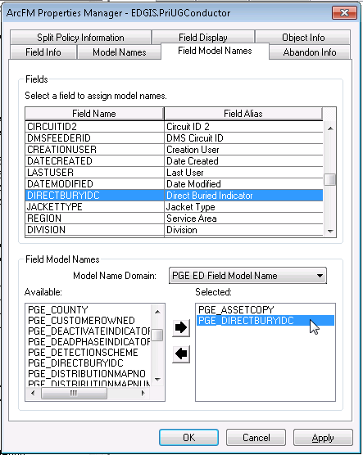

1. Click **Apply**
2. Select the **Object Info** tab
3. In the **Rules** list, check the **PGE Validate UFM Conductor** check box

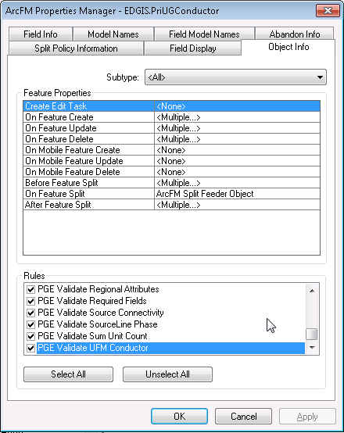

1. Click on **OK**

# TFS18978 Update Overhead Switch ComplexDeviceIDC field properties

1. Right-click on **Switch** in the Electric dataset and select **ArcFM Properties Manager**
2. Select the **Field Info** tab
3. Select the **Overhead Switch** subtype
4. Select the **COMPLEXDEVICEIDC** field
5. Update the **Allow NULL values** field from ‘**No**’ to ‘**Yes**’

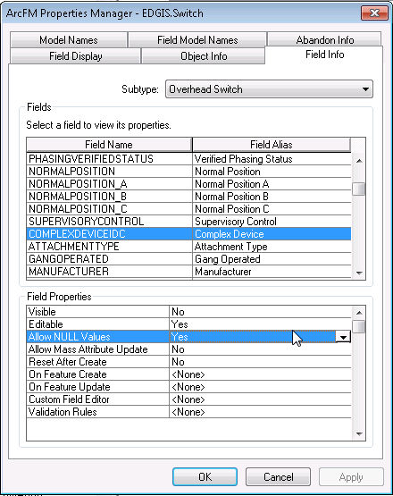

1. Click **OK**

# TFS18971 Alter Expression of StepDownAnnotation to correct short annotation. This is to fix bug 18758

1. Open ArcCatalog
2. Browse to the ElectricDataset
3. Right Click on StepDownAnno
4. Choose properties
5. Select the annotation class tab
6. Select the "StepDownVolt" Annotation class from the list.
7. Hit the expression button.
8. Copy in the expression below:

Function FindLabel ( [OperatingVoltage], [OutputVoltage], [INSTALLATIONTYPE]    )  
myOplen = len([OperatingVoltage])  
if myOplen > 1 then  
  myVolt = mid( [OperatingVoltage],myOplen-1,1)  
else  
  myVolt = ""  
end if  
myOutlen = len([OutputVoltage])  
if myOutlen > 1 then  
  myOut = mid([OutputVoltage],myOutlen-1,1)  
else  
  myOut = ""  
end if  
if myVolt = "k" then  
    myVolt = mid([OperatingVoltage],1,myOplen-2)  
else  
    if myOplen > 1 then  
      myVolt = mid([OperatingVoltage],1,myOplen-1)  
   else  
      myVolt = [OperatingVoltage]  
   end if  
end if  
if myOut = "k" then  
    myOut = mid([OutputVoltage],1,myOutlen-2)  
else  
    if myOutlen > 1 then  
      myOut = mid([OutputVoltage],1,myOutlen-1)  
    else  
      myOut = [OutputVoltage]  
    end if  
end if  
  FindLabel = myVolt + "/" + myOut  
End Function

1. Hit the **Verify** button, make sure it validates
2. Click ok
3. Click ok
4. Repeat the above steps to update the expression for the 50 scale annotation for StepDownAnnotation

# TFS18980 Drop and recreate Conduit System Anno

Conduit System Anno Replacement

## Configuration Steps

1. Log into ArcCatalog as edgis, ensuring you have **exclusive access**
2. Select ElectricDataset/ConduitSystemAnno
3. Right-click Delete
4. Select ElectricDataset FeatureDataset and New > FeatureClass  
   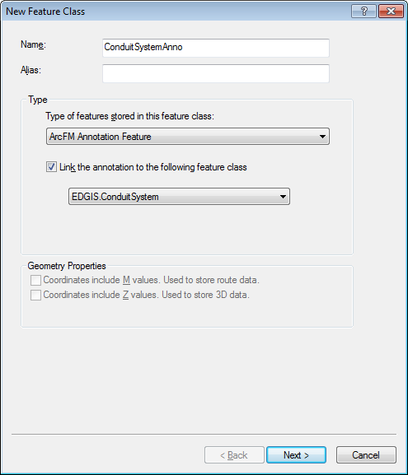
5. Click Next
6. 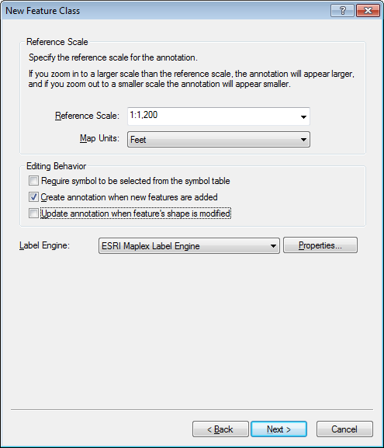  
   Click Next
7. Set Default Anno Properties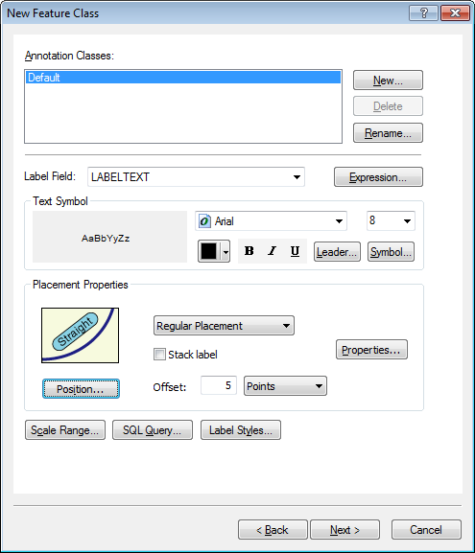
8. Click New…
9. Type in the name of ConduitNoRel   
   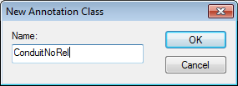
10. Fill out ConduitNoRel properties:
    1. Label Field: LABELTEXT2
    2. Text Symbol:
       1. Arial
       2. 8
       3. Black
       4. No italics, no bold, no underline set
    3. Placement:
       1. Regular Placement
       2. Offset 5

Note: The completed properties should be the exact same as default except for the Labelfield.

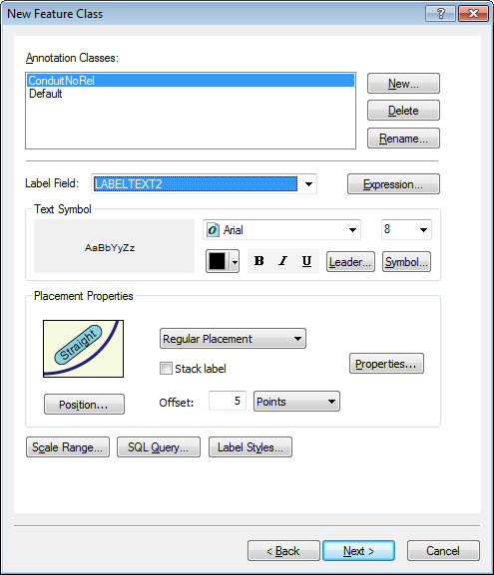

1. Click Next  
   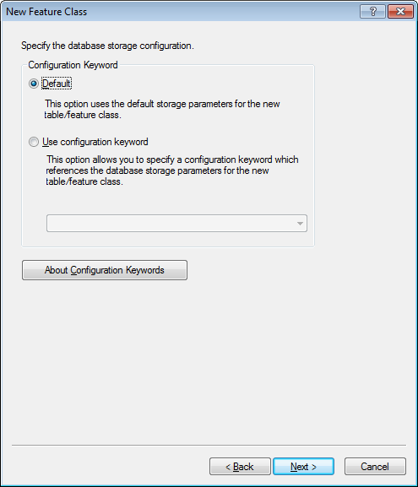  
   Click Next
2. Enter two new fields:
   1. Field Name: ConversionWorkPackage
      1. Type: TEXT
      2. Allow Null Values : Yes
      3. Length: 6
      4. Domain: Conversion Work Package
      5. Alias : <Leave this blank>
      6. Default Value: <Leave this blank>

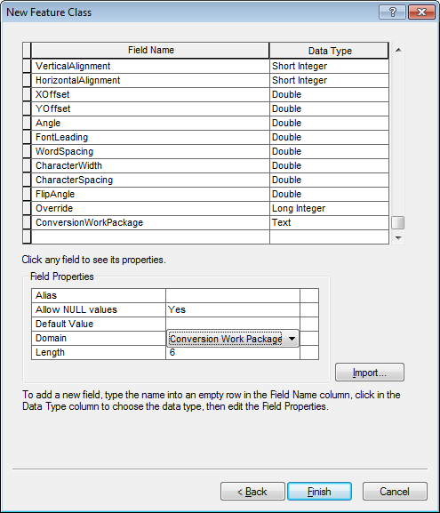

* 1. Field Name:FeatureConversionID
     1. Type: Long Integer
     2. Precision: 10
     3. Allow Null Values : yes
     4. Domain: <Leave this blank>
     5. Alias : <Leave this blank>
     6. Default Value: <Leave this blank>

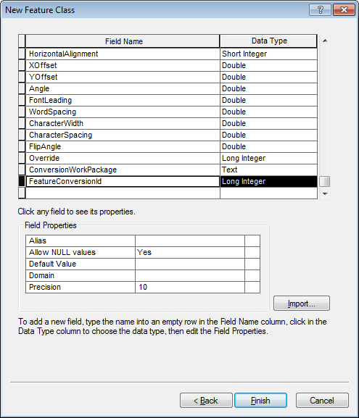

1. Click Finish
2. Rename the newly created relationship class EDGIS.Anno_####_#### to EDGIS.ConduitSystemAnnoRel  
   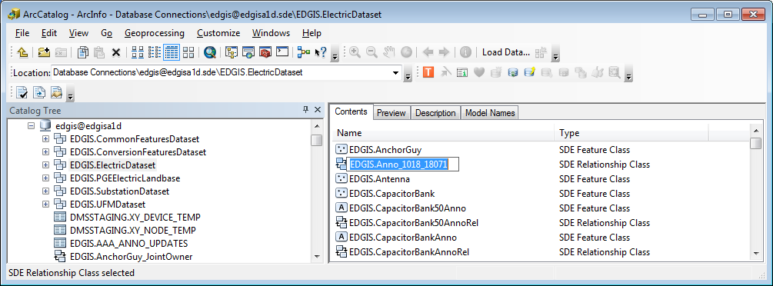  
   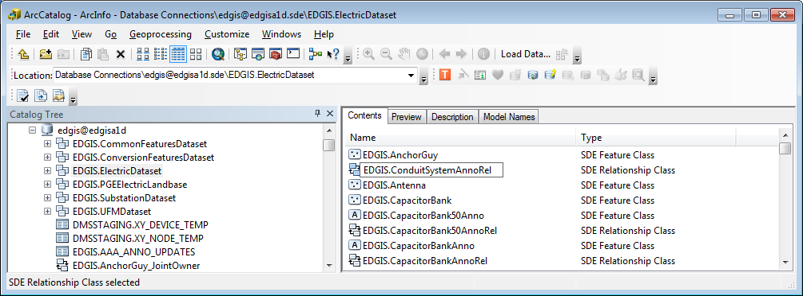
3. Verify Subtype Codes…
   1. Code 0 = Desciption “Default”
   2. Code 1 = Desciption “ConduitNoRel”

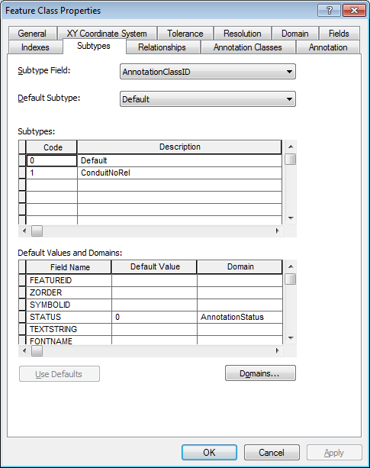

1. Right-click ElectricDataset > Add Global Ids , Click yes on the dialog   
   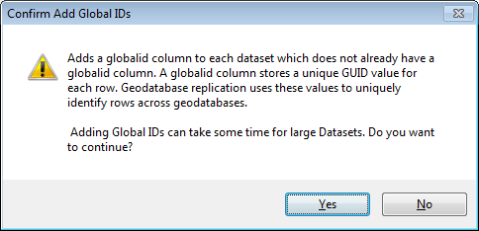
2. ConduitSystemAnno > Properties | Indexes tab  
   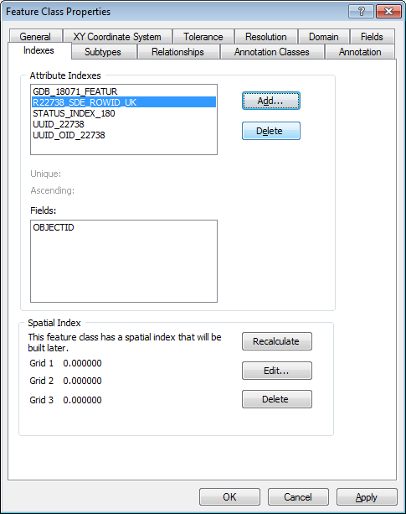
3. Click the “Add…” button:
   1. Name: IDX_CONDUITSYSTEMANNO_CONVID
   2. Fields Selected choose:
      1. In the left hand side select FEATURECONVERSIONID and move it to the right hand side using the arrow buttons.

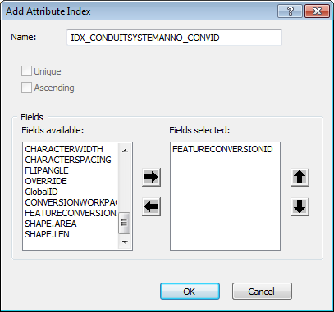

* 1. Click OK

1. In ArcCatalog, right-click the database connection & ArcFM XML Import  
   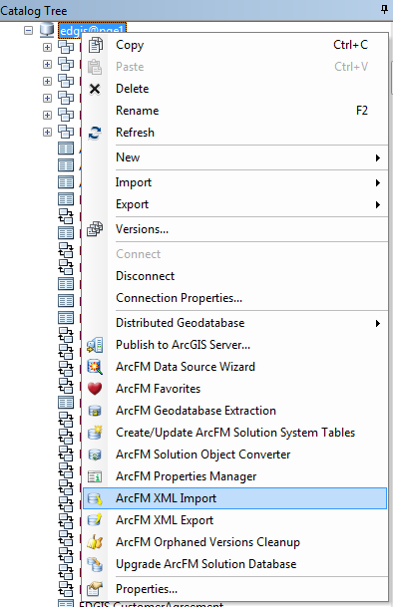
2. Select Overwrite and set path to   
   \\sfetgis-nas01\sfgispoc_data\ApplicationDevelopment\IBM_TeamMembers\PhilPenn\arcfmprops_conduitsystemanno_93.xml  
   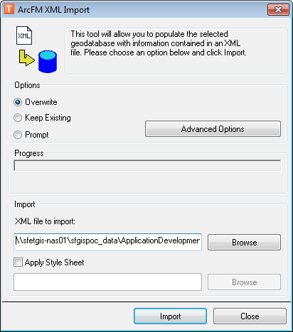  
   Click Import. Ensure no errors occur.
3. In ArcCatalog, right-click EDGIS.ConduitSystem_SecUG > ArcFM Properties Manager  
   Set all 3 events to “PGE LabelText Symbol Number Combo” S  
   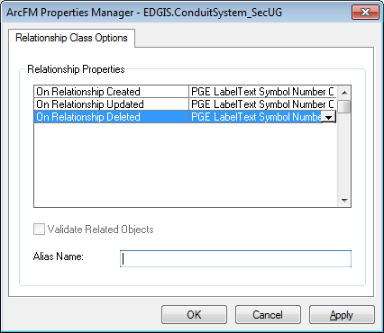  
   Click OK
4. Repeat previous step for EDGIS.ConduitSystem_PriUG
5. Go into every Stored Display that references “Anno – Conduit” and remove and re-add the ConduitSystemAnno layer.
6. Assign privledges on the ElectricDataset for the following users and roles:

SDE_VIEWER **Read**GIS_I **Read**BO_USER**Read**DATACONV**Read**DMSSTAGING**Read**GIS_INTERFACE**Read**GISINTERFACE**Read**EDGISBO

SDE_EDITOR**Read/Write**GIS_I_WRITE**Read/Write**DAT_EDITOR**Read/Write**

# TFS 19000 Transformer Type Domains Change

1. Right click the target database and select Properties.
2. In the Domains tab, scroll to the Trans Unit Type Overhead domain.
3. Select all values and press Delete.
4. Click Apply.
5. Repeat the previous steps for the following domains: Trans Unit Type Surface, Trans Unit Type Subsurface.
6. Download the "add" Python scripts locally. The location for these scripts can be found in Section 1.3.
7. Change the Database Connection string in each one of them to use the correct SDE connection file.
8. Apply the "add" Python scripts and save the log files as attachments to the TFS ticket.

# TFS19012 Remove Relationship Rules and add Pge_Generator Model Name to Inverter.

1. Open ArcCatalog, browse to the ProtectiveDevice_Inverter relationship in the root of the connection.
2. Right Click and select properties.
3. Select the Rules Tab
4. You MUST select the Protective Device in the Origin top window.
5. Then you MUST select the inverter in the bottom window.

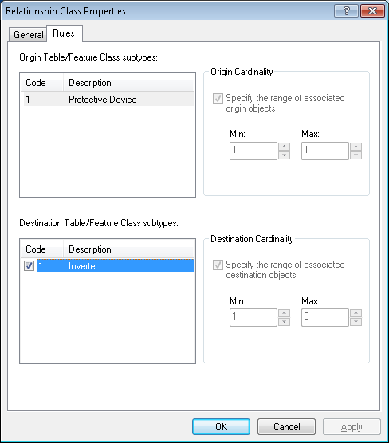

1. Now you will be able to uncheck the Cardinality check boxes and also uncheck the inverter check box for code.
2. Now hit the ok button
3. Select the Inverter Table in the root of the system.
4. Right click and choose ArcFM properties.
5. Select the Model Names Tab
6. Choose the Model Name domain of “PGE ED Object Clas Model Name”
7. Assign the "PGE_GENERATOR" model name and hit ok.

# TFS19006 Apply Production Connectivity Rules

1. Open ArcCatalog and launch the GDBDesigner tool.
2. Import the following file:

<http://edappgistfsprd1:8080/tfs/ElectricDistCollection/EDAMGIS/_workitems#_a=edit&id=19006>

1. The file can be found as an attachment to the above linked TFS ticket.

# [TFS 18979:](http://edappgistfsprd1:8080/tfs/ElectricDistCollection/EDAMGIS/_workitems/edit/18979) EDGIS.NeutralConductorAnno Annotation Class configuration

 1. Open ArcCatalog

2. Ensure you have exclusive access to the EDGIS user.

3. Navigate to EDGIS.NeutralConductorAnno. Right click on it. Select "Properties..."

4. Go to "Annotation Classes" tab. Select Default. Click on "Expression" button.

5. **Uncheck** "Advanced" checkbox.

6. Click OK. Click Apply. Click OK.

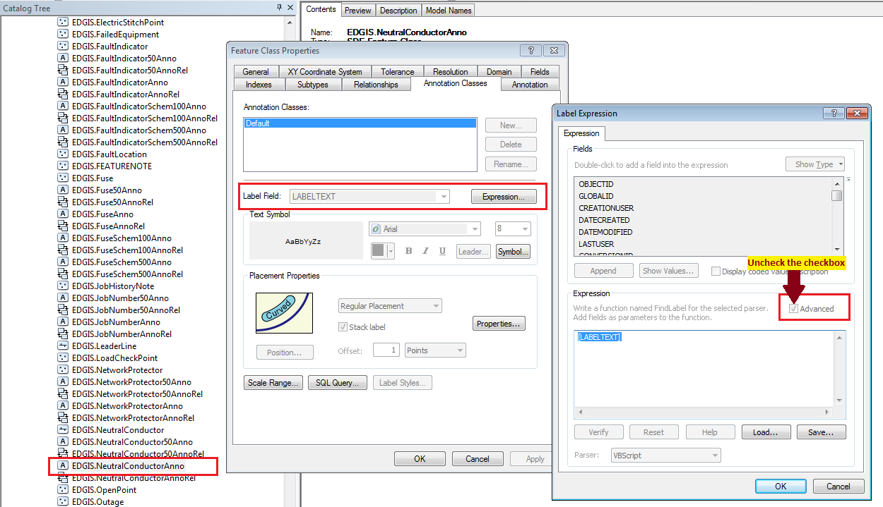

# Update relationship aliases – Change the “Labels” (Forward and Backward)

Drop and recreate following relationship classes as listed below:

1. EDGIS.ConduitSystem50AnnoRel
2. EDGIS.CapacitorBank50AnnoRel
3. EDGIS.CrossSection50AnnoRel
4. EDGIS.CustAgreeNumber50AnnoRel
5. EDGIS.DCConductor50AnnoRel
6. EDGIS.DCDevice50AnnoRel
7. EDGIS.DCRectifier50AnnoRel
8. EDGIS.DeactivatedElecLineSeg50AnnoRel
9. EDGIS.DeliveryPoint50AnnoRel
10. EDGIS.DeviceGroup50AnnoRel
11. EDGIS.DistBusBar50AnnoRel
12. EDGIS.DynProtDevice50AnnoRel
13. EDGIS.FaultIndicator50AnnoRel
14. EDGIS.Fuse50AnnoRel
15. EDGIS.JobNumber50AnnoRel
16. EDGIS.NetworkProtector50AnnoRel
17. EDGIS.NeutralConductor50AnnoRel
18. EDGIS.PrimaryGeneration50AnnoRel
19. EDGIS.PriOHConductor50AnnoRel
20. EDGIS.PriUGConductor50AnnoRel
21. EDGIS.SecOHConductor50AnnoRel
22. EDGIS.SecondaryGeneration50AnnoRel
23. EDGIS.SecUGConductor50AnnoRel
24. EDGIS.StepDown50AnnoRel
25. EDGIS.StreetLight50AnnoRel
26. EDGIS.Substation50AnnoRel
27. EDGIS.SubsurfaceStructure50AnnoRel
28. EDGIS.SupportStructure50AnnoRel
29. EDGIS.Switch50AnnoRel
30. EDGIS.Transformer50AnnoRel
31. EDGIS.VaultPoly50AnnoRel
32. EDGIS.VoltageRegulator50AnnoRel

## EDGIS.ConduitSystem50AnnoRel

**Steps:**

1. Open ArcCatalog.
2. Get exclusive access of the EDGIS user.
3. Navigate to EDGIS.ConduitSystem50AnnoRel. Right click on it. Select “Properties…”
4. Check the “Labels” values. They should not contain “**EDGIS.**” prefix. **If any one of the labels (Forward or Backward) has this prefix, the relationship class has to be deleted and recreated again.**

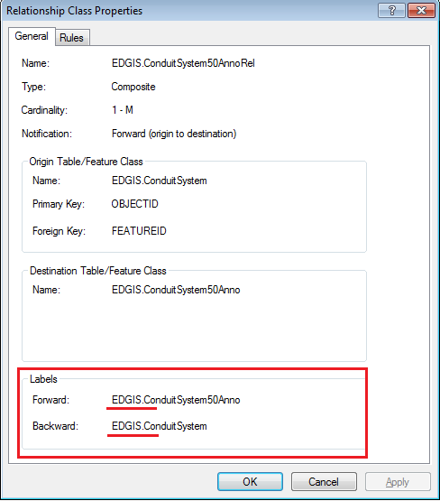

**Bad labels**

1. If the labels are incorrect, Click Cancel. Right click on the relationship class, Click on “Delete” option.

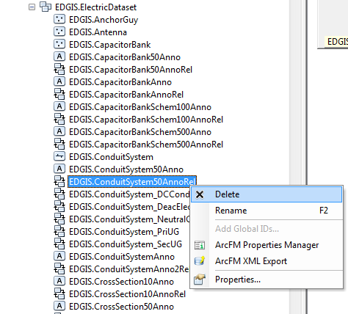

1. Right click on ElectricDataset. Select New 🡪 Relationship Class…

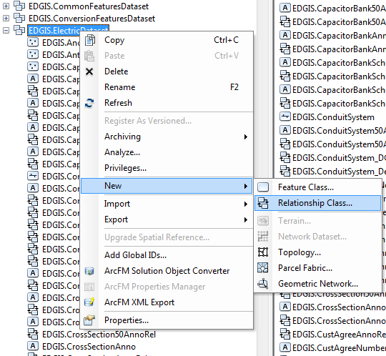

1. Provide the name and other properties as given below:

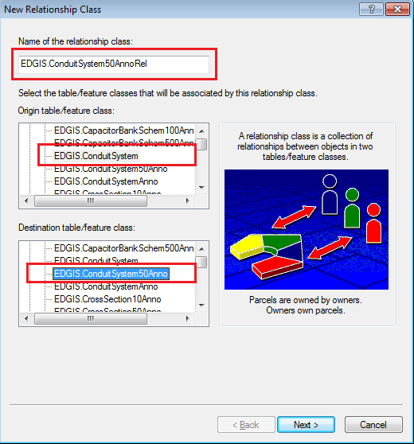

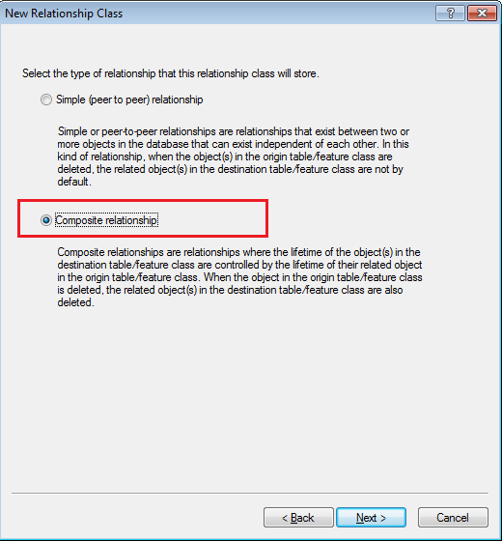

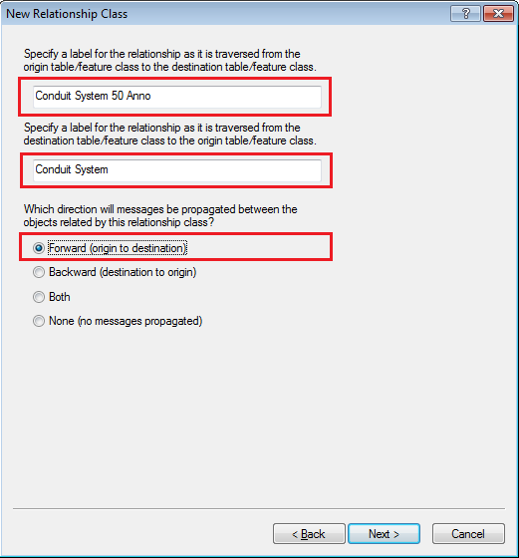

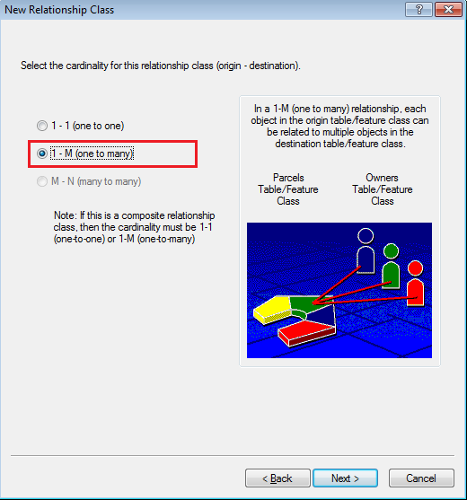

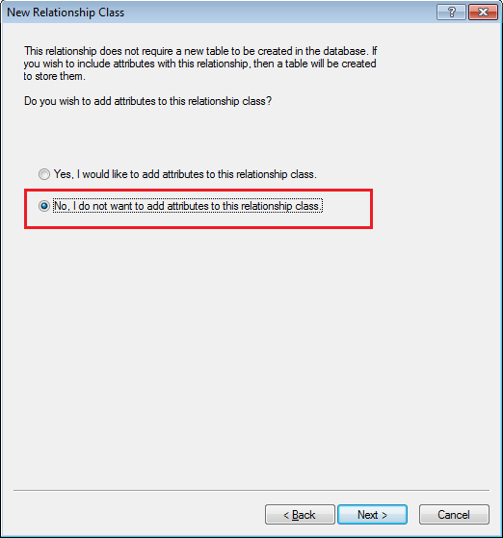

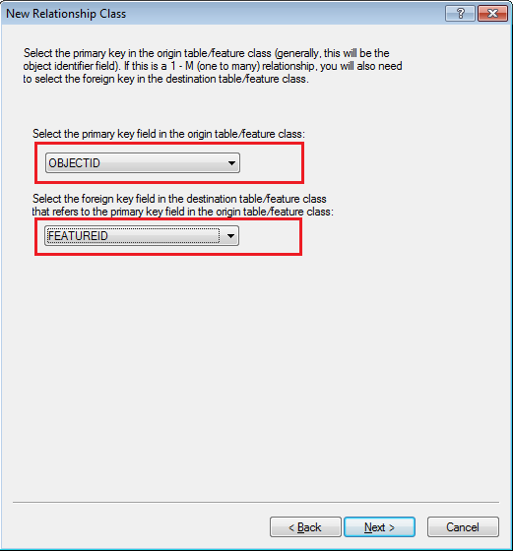

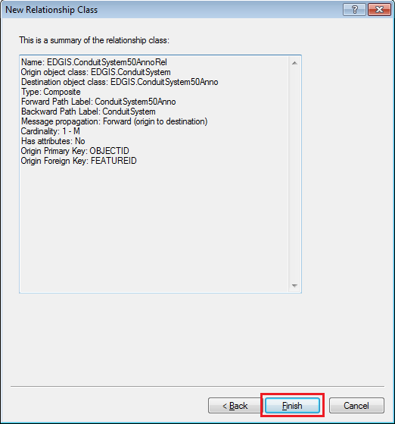

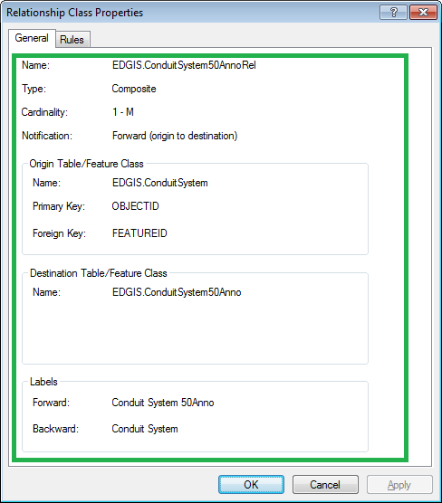

**Good labels**

1. Reconstruct other relationship classes using the same steps. The details are as given below.

## EDGIS.CapacitorBank50AnnoRel:

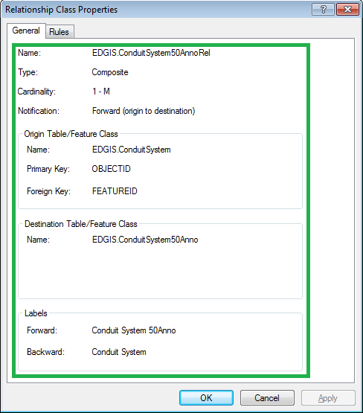

## EDGIS.CrossSection50AnnoRel:

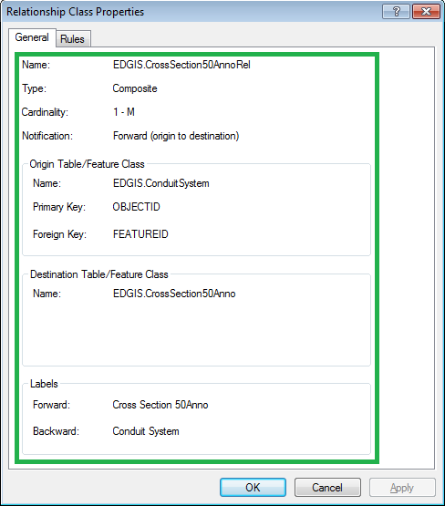

## EDGIS.CustAgreeNumber50AnnoRel:

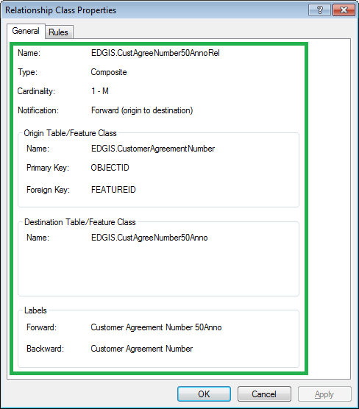

## EDGIS.DCConductor50AnnoRel:

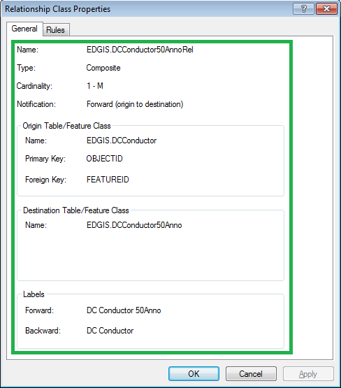

## EDGIS.DCDevice50AnnoRel:

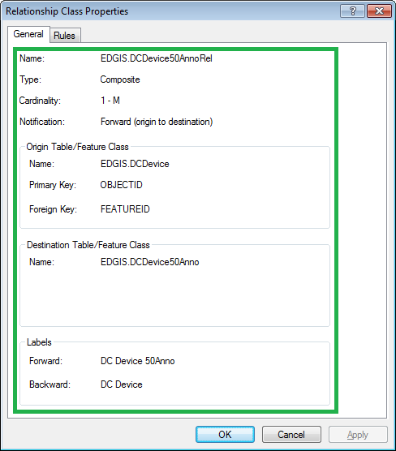

## EDGIS.DCRectifier50AnnoRel:

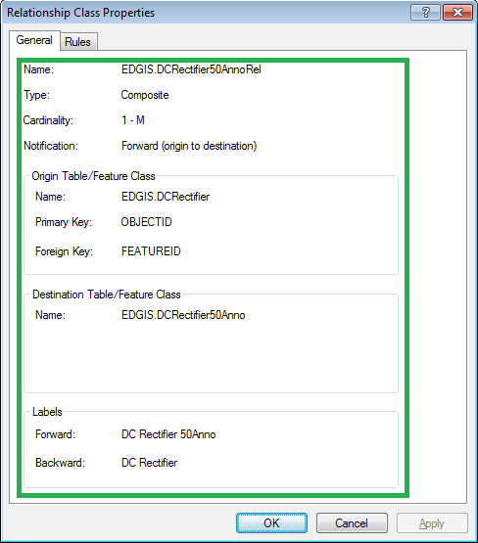

## EDGIS.DeactivatedElecLineSeg50AnnoRel:

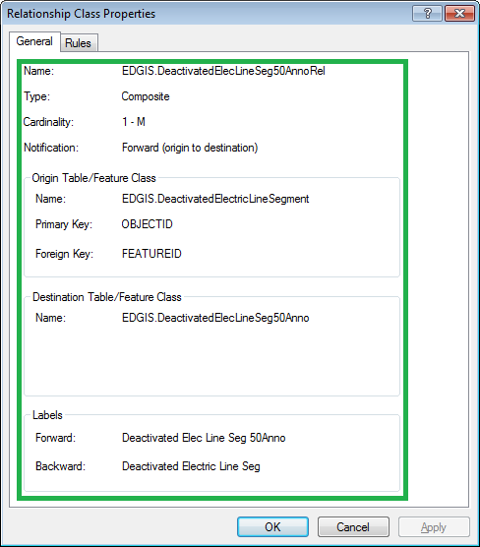

## EDGIS.DeliveryPoint50AnnoRel:

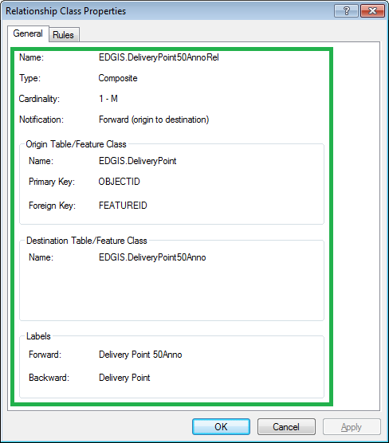

## EDGIS.DeviceGroup50AnnoRel:

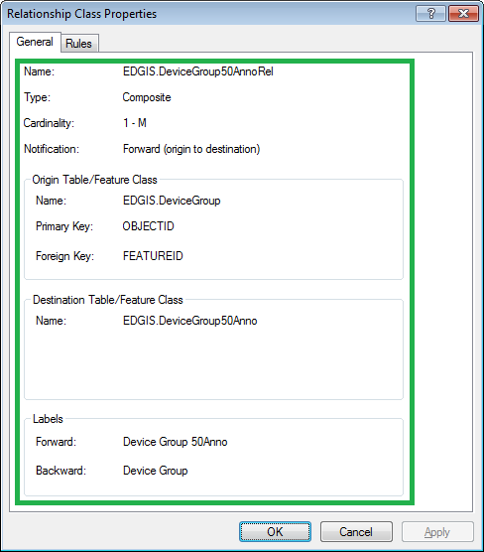

## EDGIS.DistBusBar50AnnoRel:

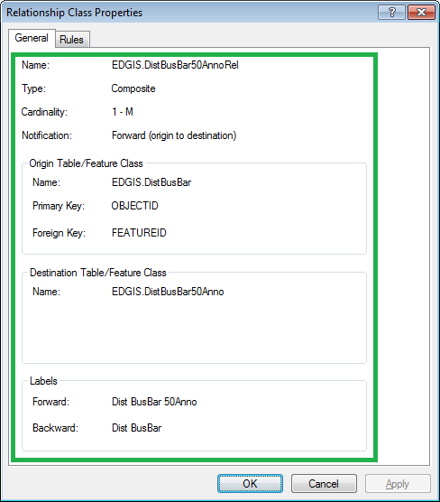

## EDGIS.DynProtDevice50AnnoRel:

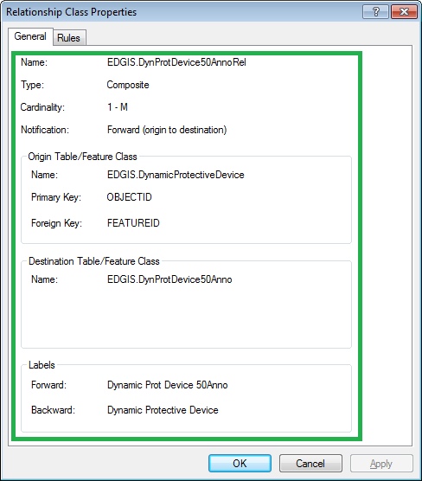

## EDGIS.FaultIndicator50AnnoRel:

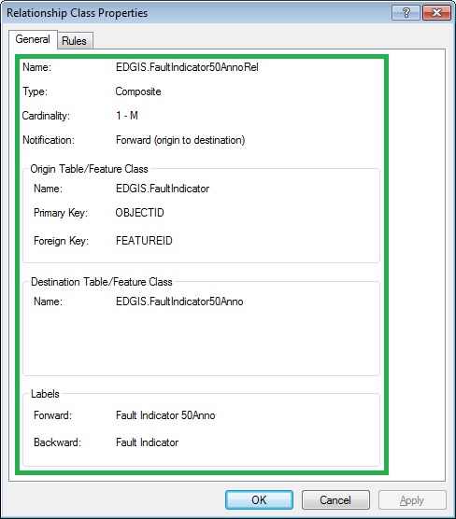

## EDGIS.Fuse50AnnoRel:

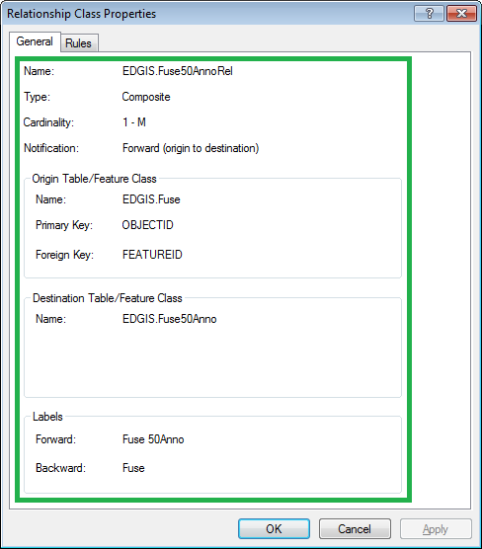

## EDGIS.JobNumber50AnnoRel:

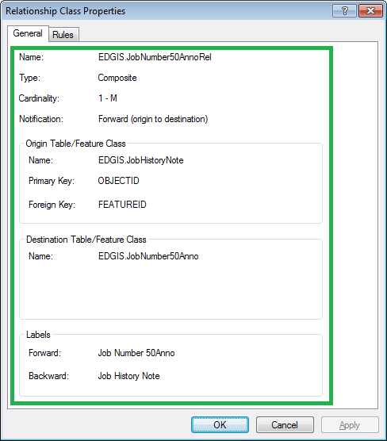

## EDGIS.NetworkProtector50AnnoRel:

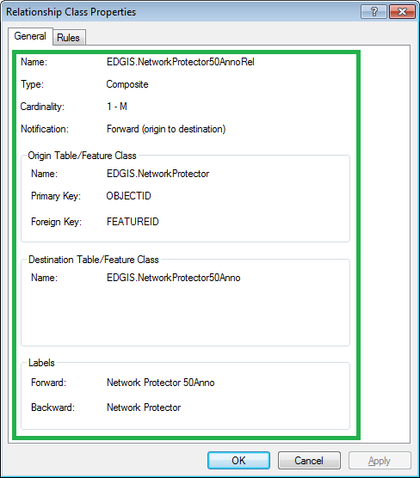

## EDGIS.NeutralConductor50AnnoRel:

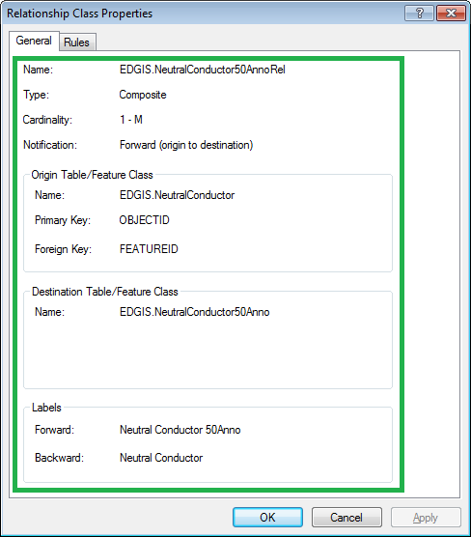

## EDGIS.PrimaryGeneration50AnnoRel:

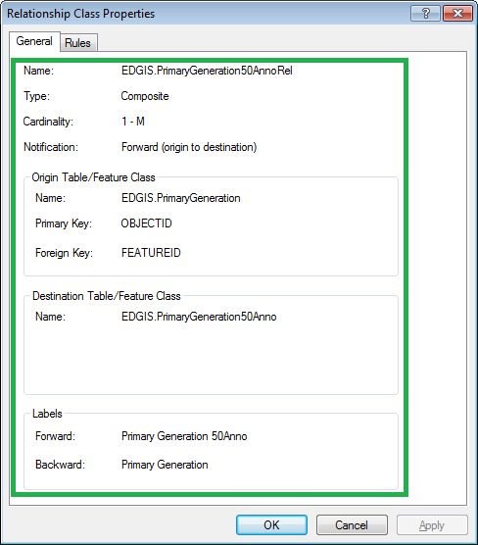

## EDGIS.PriOHConductor50AnnoRel:

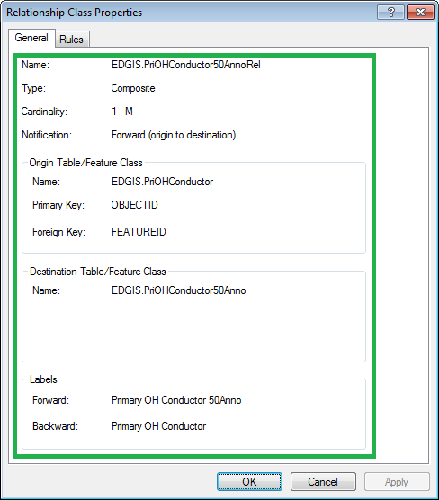

## EDGIS.PriUGConductor50AnnoRel:

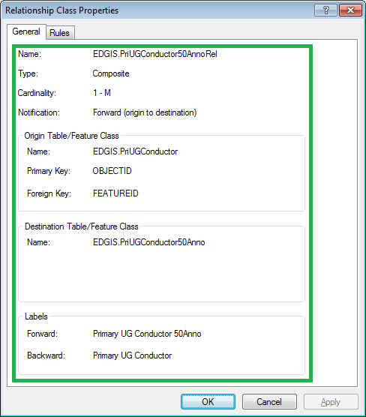

## EDGIS.SecOHConductor50AnnoRel:

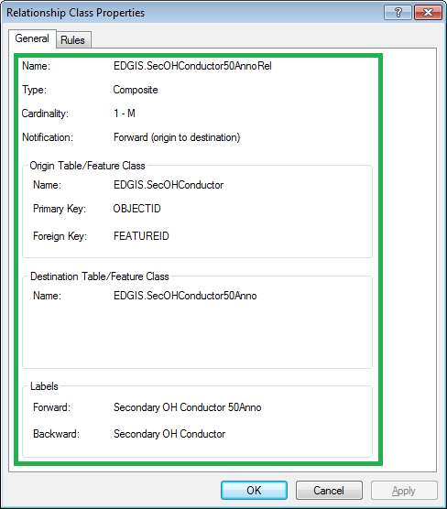

## EDGIS.SecondaryGeneration50AnnoRel:

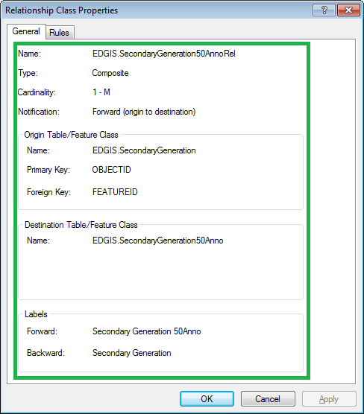

## EDGIS.SecUGConductor50AnnoRel:

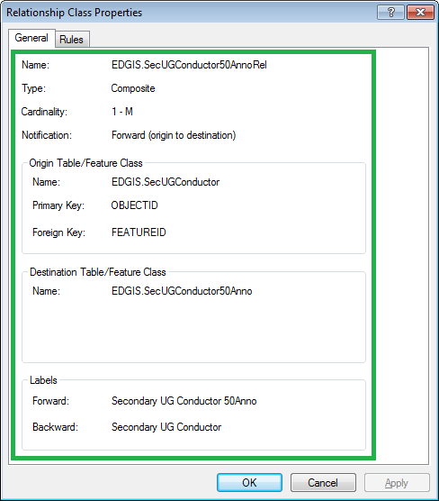

## EDGIS.StepDown50AnnoRel:

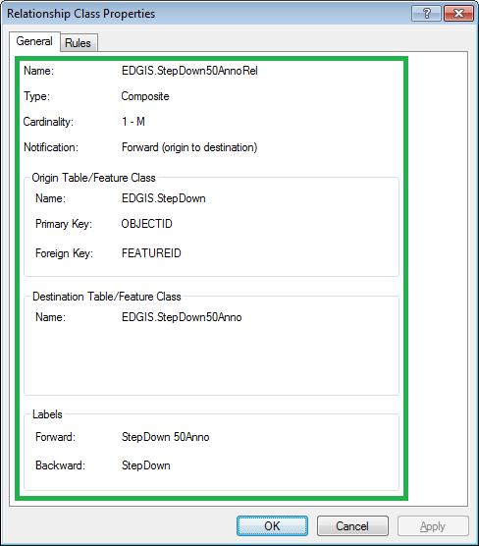

## EDGIS.StreetLight50AnnoRel:

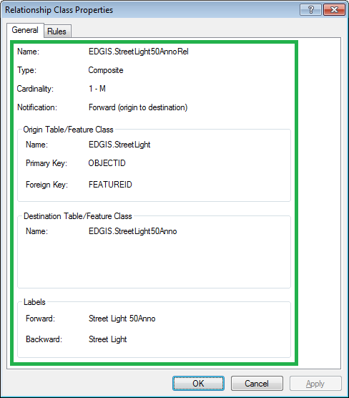

## EDGIS.Substation50AnnoRel:

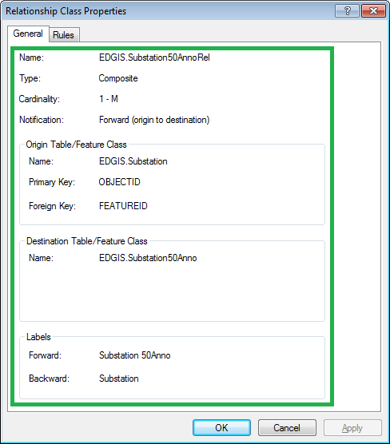

## EDGIS.SubsurfaceStructure50AnnoRel:

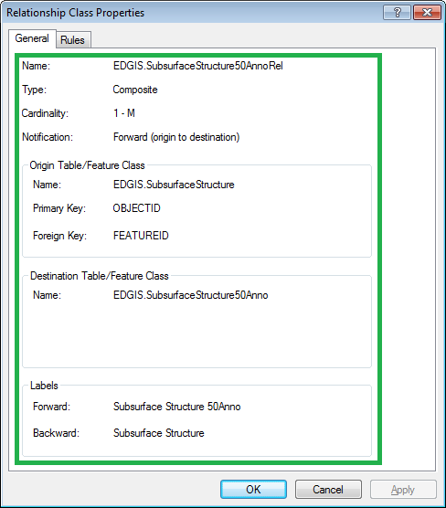

## EDGIS.SupportStructure50AnnoRel:

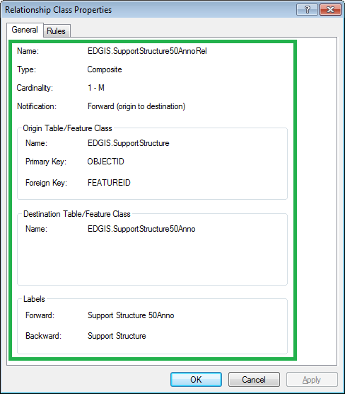

## EDGIS.Switch50AnnoRel:

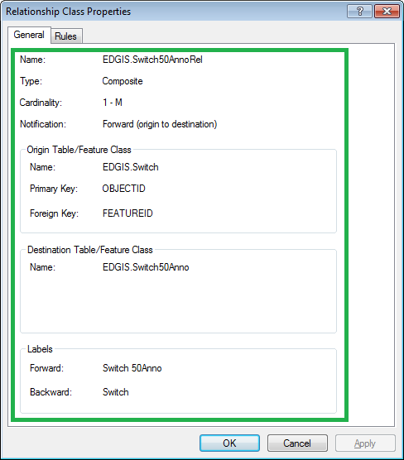

## EDGIS.Transformer50AnnoRel:

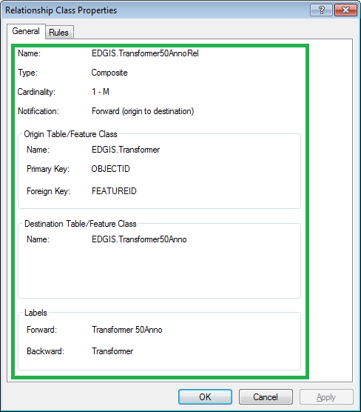

## EDGIS.VaultPoly50AnnoRel:

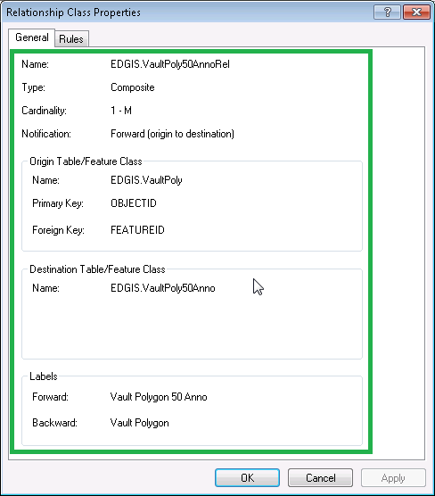

## EDGIS.VoltageRegulator50AnnoRel:

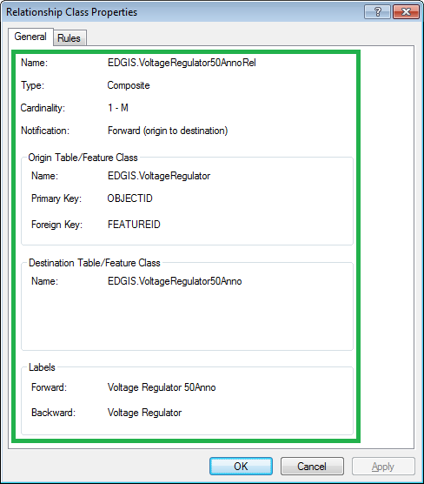

# TFS19026 – Update Direction attribute on ConduitSystem

1. Right-click on **ConduitSystem** in the Electric dataset and select **ArcFM Properties Manager**.
2. Select the **FieldInfo** tab
3. Select the **DuctBank** subtype
4. Navigate to the **Direction** field
5. Set the **Visible** property to **Yes**

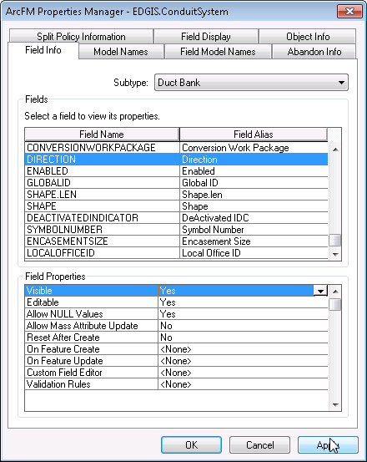

1. Click on **OK**

# TFS 19062 Assign Nominal Voltage AU to Primary Overhead Conductor : PriOHConductor

1. Open ArcCatalog
2. Select the ElectricDataset\PriOHConductor featureclass
3. Right click and choose “ArcFM Properties”
4. Select the Object_Info Tab
5. Choose the On Feature Create option of “Multiple”
6. In the Autoupdaters available select the “PGE Inherit Nominal Voltage AU” and move it to the Autoupdaters selected list.
7. Move the newly assigned AU above the LabelText AU in the list.

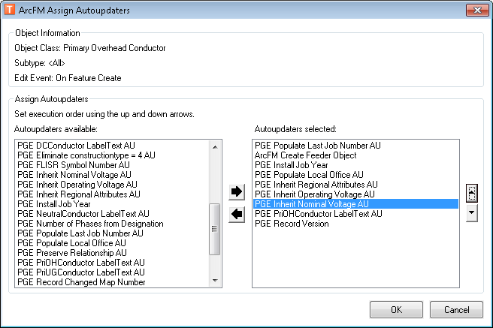

1. Hit the “OK” button
2. Choose the On Feature Update option of “Multiple”
3. In the Autoupdaters selected list, move the PGE Inherit Nominal Voltage AU above the PGE PriOHConductor LabelText AU.

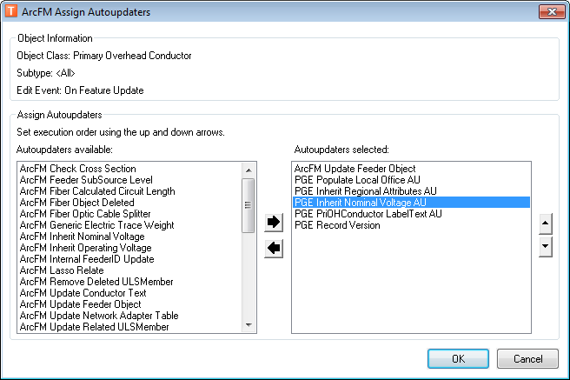

1. Hit the “OK” button
2. Hit “OK” to close the ArcFM Properties Manager

# TFS 19020 Update Map Prod 1.0 and 2.0 Table updates

1) Open up ArcCatalog and connect to desired database as the EDGIS user.

2) Right click on the EDGIS.PGE_CHANGEDETECTIONGRIDS table and select Delete and confirm.

3) Open up a sqlplus command prompt and log in to the desired database as the EDGIS user.

4) Execute the following sql commands.

CREATE TABLE EDGIS.PGE_CHANGEDETECTIONGRIDS(

  MAPNUMBER            NVARCHAR2(15),

  GRIDCHANGEDDATE      DATE,

  MAPPRODUCTION_ERROR  NVARCHAR2(2000),

  EXPORTSTATE          NVARCHAR2(10),

  MAP_TYPE             NVARCHAR2(50),

  SCALE                NVARCHAR2(10),

  FAILURECOUNT         NUMBER                   DEFAULT 0,

  STARTDATE            DATE,

  ENDDATE              DATE,

  MACHINENAME          NVARCHAR2(20),

  SERVICETOPROCESS     INTEGER,

  ERRORMSG             NVARCHAR2(255),

  PRIORITY             INTEGER                  DEFAULT 3);

COMMIT;

CREATE TABLE EDGIS.PGE_CHANGEGRIDS_ARCHIVE(

  MAPNUMBER            NVARCHAR2(15),

  GRIDCHANGEDDATE      DATE,

    MAPPRODUCTION_ERROR  NVARCHAR2(2000),

  EXPORTSTATE          NVARCHAR2(10),

  MAP_TYPE             NVARCHAR2(50),

  SCALE                NVARCHAR2(10),

  FAILURECOUNT         NUMBER                   DEFAULT 0,

  STARTDATE            DATE,

  ENDDATE              DATE,

  MACHINENAME          NVARCHAR2(20),

  SERVICETOPROCESS     INTEGER,

  ERRORMSG             NVARCHAR2(255),

  PRIORITY             INTEGER                  DEFAULT 3,

  ARCHIVEDATE           DATE);

ALTER TABLE

   EDGIS.PGE_MAPNUMBERCOORDLUT

add

   (

   MAPSTATUS VARCHAR2(2000 BYTE),

   EXPORTSTARTDATE   DATE,

   EXPORTENDDATE     DATE,

   SERVEREXPORTEDFROM VARCHAR2(2000 BYTE)

   );

5) Open a new ArcCatalog session and connect to the desired database as the EDGIS user.

6) Right click on the "EDGIS.PGE_CHANGEDETECTIONGRIDS table.

7) Select the option to Register the table with the geodatabase (DO NOT register as versioned).

8) Right click on EDGIS.PGE_CHANGEDETECTIONGRIDS table

9) Select permissions

10) Configure the following permissions

-Grant edit privileges to SDE and GIS_I

-Grant read privileges to edgis_metrics_ro

11) Repeat steps 6-10 for the EDGIS.PGE_CHANEGRIDS_ARCHIVE table.

12) Back in the sqlplus window execute the following:

select registration_id from sde.table_registry where table_name = 'PGE_CHANGEGRIDS_ARCHIVE';

13) The above query provides a number.  Modify the below trigger (PGE_CD_GRIDS_TRIGGER) creation statement and replace<VAL> with the number given in the previous query.

14) Execute the modified sql below

CREATE OR REPLACE TRIGGER PGE_CD_GRIDS_TRIGGER

AFTER UPDATE  OF ENDDATE ON

  EDGIS.PGE_CHANGEDETECTIONGRIDS

 FOR EACH ROW

DECLARE

BEGIN

if UPDATING('ENDDATE') then

 -- Insert the row being deleted from PGE_CHANGED_CIRCUIT table into PGE_CHANGED_CIRCUIT_ARCHIVE table for permanent history

INSERT INTO EDGIS.PGE_CHANGEGRIDS_ARCHIVE

(ENDDATE,

ERRORMSG,

EXPORTSTATE,

FAILURECOUNT,

GRIDCHANGEDDATE,

MACHINENAME,

MAPNUMBER,

MAPPRODUCTION_ERROR,

MAP_TYPE,

OBJECTID,

PRIORITY,

SCALE,

SERVICETOPROCESS,

STARTDATE,

ARCHIVEDATE

)

VALUES(

 :new.ENDDATE,

:new.ERRORMSG,

:new.EXPORTSTATE,

:new.FAILURECOUNT,

:new.GRIDCHANGEDDATE,

:new.MACHINENAME,

:new.MAPNUMBER,

:new.MAPPRODUCTION_ERROR,

:new.MAP_TYPE,

 EDGIS.R<VAL>.nextval,

:new.PRIORITY,

:new.SCALE,

:new.SERVICETOPROCESS,

:new.STARTDATE,

 CURRENT_DATE

 );

 END IF;

END;

/

# Data Model Version Table

**Database Configuration:**

1. Open SQL Plus.
2. Log in using the same server and user as was used in section 2.  
     
   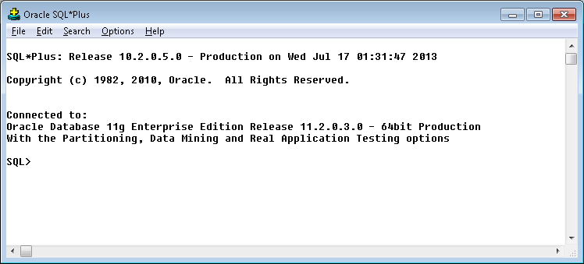
3. Run the SQL below:

update pgedatamodelversion set currentidc='N' where currentidc='Y';

insert into pgedatamodelversion (OBJECTID, CURRENTIDC, DATEAPPLIED, APPLIEDBYPERSONNAME, MODELVERSION) values (**INSERT NEXT VALID ID**,'Y',sysdate,'**<INSERT TEAM MEMBER DONE BY>**','**9.3.1** GOLD **CR19095**');

commit;

# Known Issues

<Please List any other issues encountered here while following the document>